1] NetFare vs Weekday:

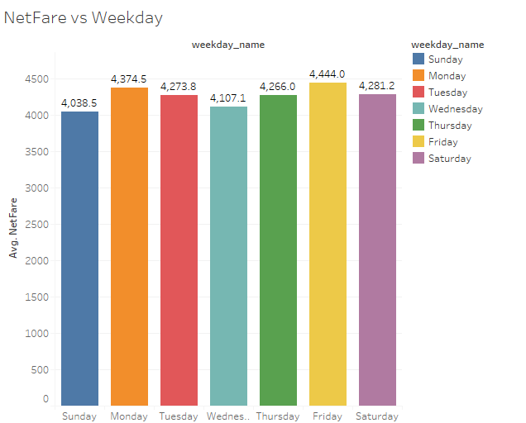

2]Domestic NetFare vs Weekday:

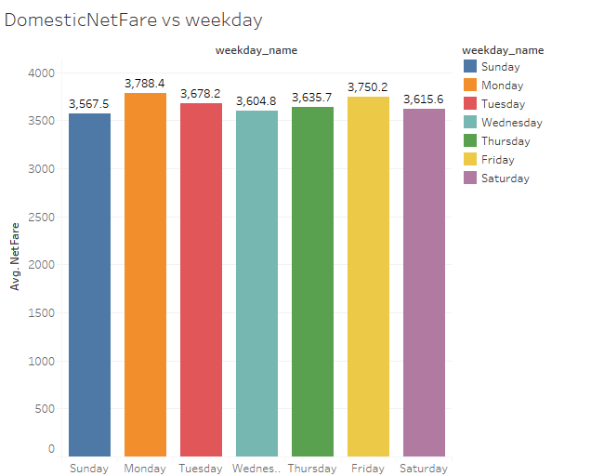

3]International NetFare vs Weekday:

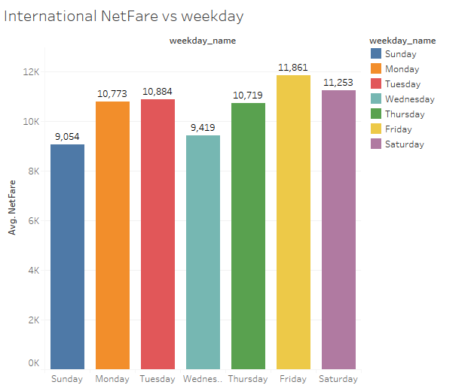

4]Domestic Netfare of 2018 vs weekday:

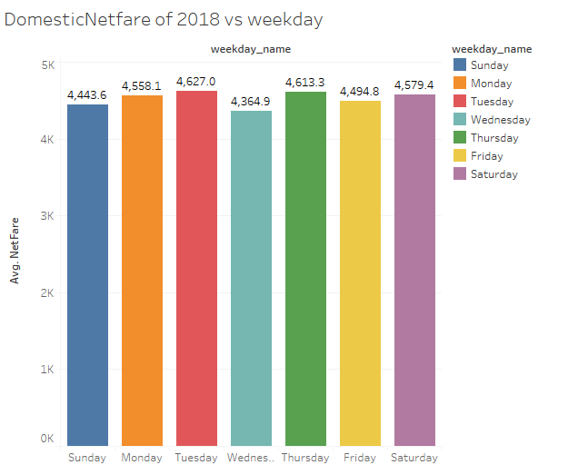

5]International Netfare of 2018 vs weekday:

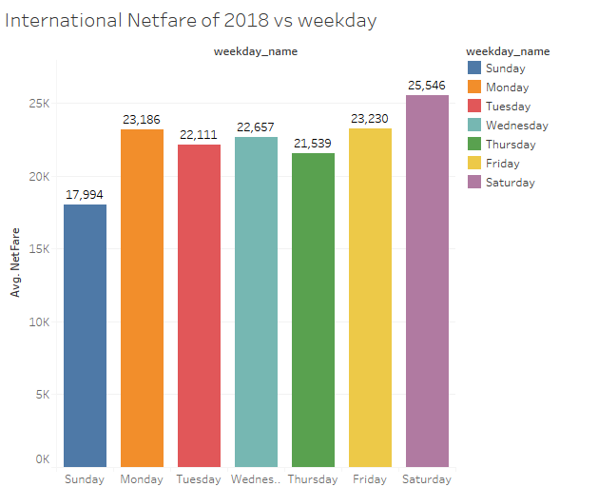

6]Domestic Netfare of 2019 vs weekday:

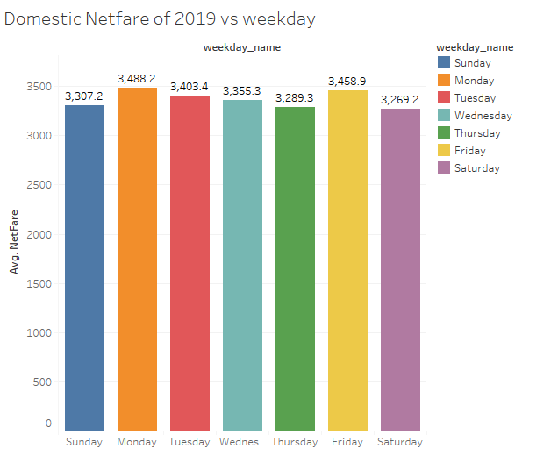

7]International Netfare of 2019 vs weekday:

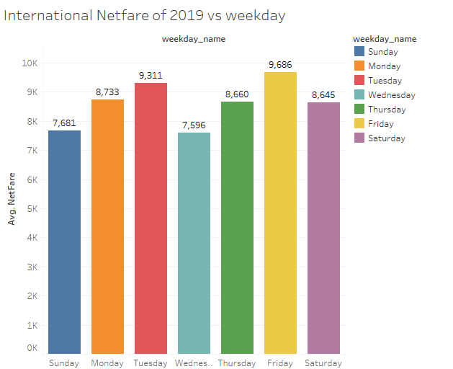

8]Hourly NetFare vs weekday:

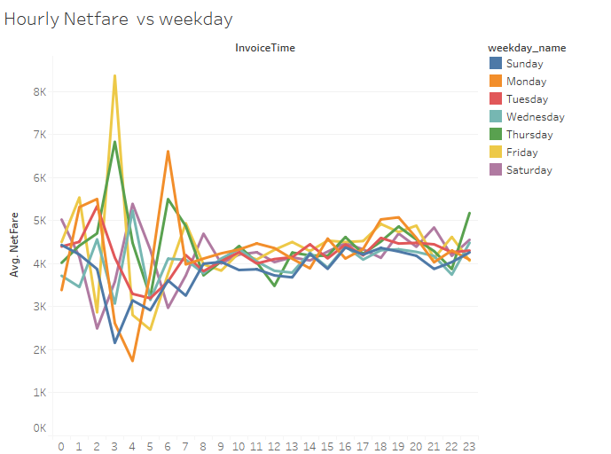

9]Hourly NetFare of Domestic vs weekday:

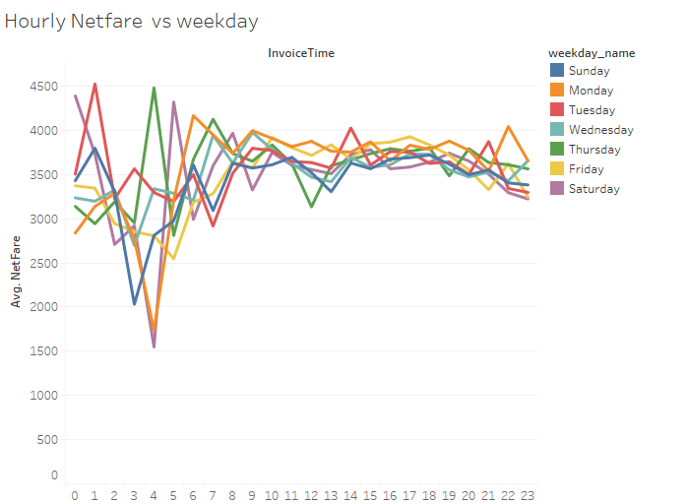

10]Hourly NetFare of International vs weekday:

